Hands-on Exercise No. 3 - DigiSkills 3.0 Batch-03 - AI Using Python
Contents
Problem Statement 2
Step 1- Imported required Libraries 3
Step 2- Load data set into pandas data frame and display first 10 rows 3
Step 3- Data Analysis (EDA) 5
Dataset Shape 5
Dataset information 5
Missing value identification 6
Generate summary statistics of numerical features 7
Check the distribution of the target variable “SalePrice” 9
Visualize the distribution of target variables 10
Step 4- Pre-Processing of data 11
4-a: Handle Missing Values 11
4-b: Drop Non-Essential Columns 11
4-c: Check Missing Values in Labelled Dataset 12
4-d: Check for duplicate values 12
4-e: Separate Categorical and Numerical columns 13
4-f. Fill missing numerical & categorical values and Validate values 14
4-i. Validate Duplicate Removal 14
4-j: Encode Categorical Variables 16
4-k: Separate Features and Target Variable 17
Task1-Train-Test Split 18
Task2-Train Model 19
Task3-Model Prediction 22
Task4-Model Evaluation 23
Task5-Interpretaton 25

Problem Statement
  - 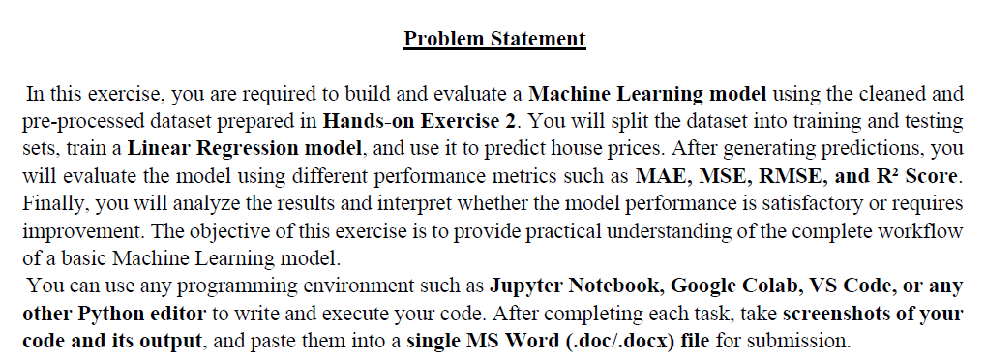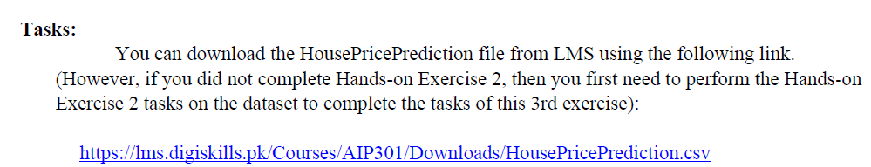
Raw Facts
  - 2,919 rows
  - 13 columns
  - Target column = SalePrice, 1,460 rows have SalePrice

Step 1- Imported required Libraries
We imported all the required libraries earlier because the problem statement had already specified, what is required:
Code
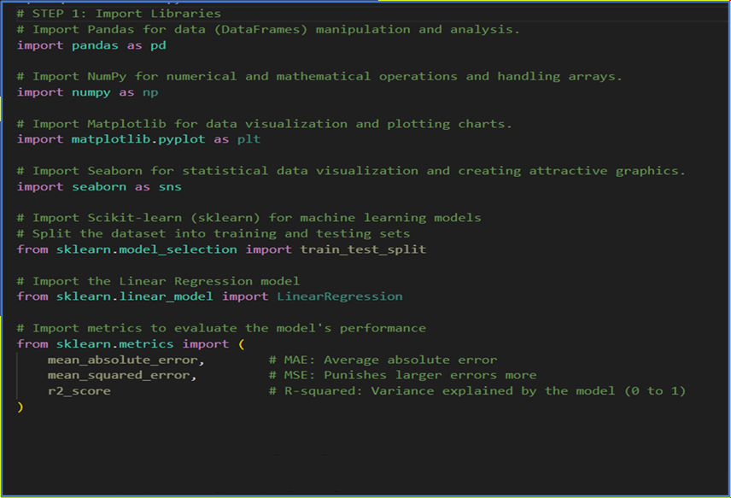

Step 2- Load data set into pandas data frame and display first 10 rows
Code
      - 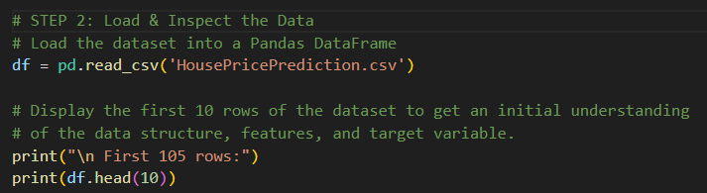
Output
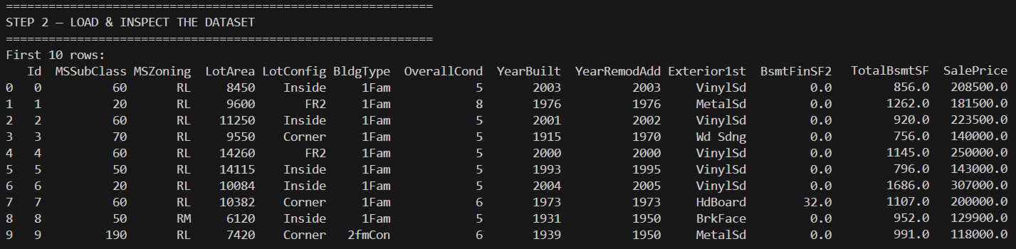
SalePrice: This is our target variable for machine learning and it is numerical because we are trying to predict a continuous number value. In data science, predicting a specific number always equals a Regression problem.

Step 3- Data Analysis (EDA)
Performed data analysis by displaying the dataset’s shape, checking the data types of the columns, and generating a statistical summary of numerical values.

Dataset Shape
Code
Output

Dataset information
Code
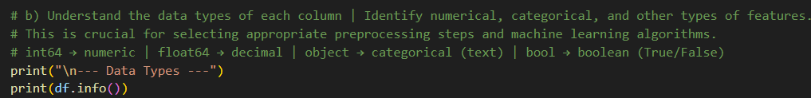

Output
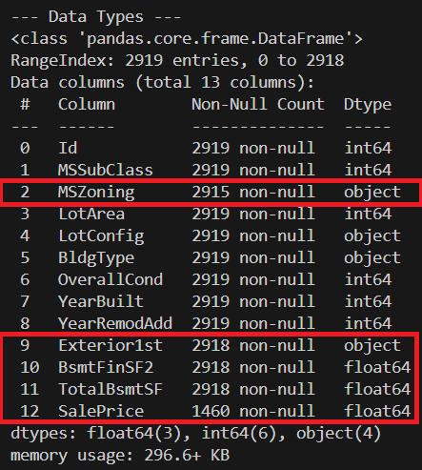
The dataset occupies approximately 296.6 KB of memory in RAM. Some variables contain missing values. Missing values need to be handled before machine learning model training through removal or imputation. The Id column contains 2919 records with no missing values.
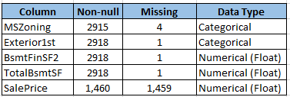

Missing value identification
Code
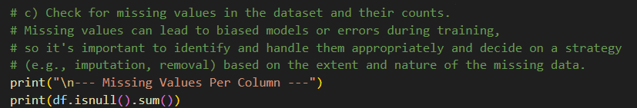
Output
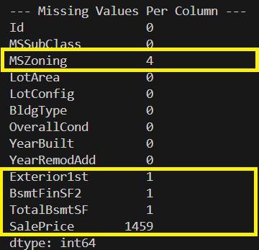

Generate summary statistics of numerical features
Code
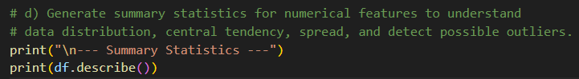

Output
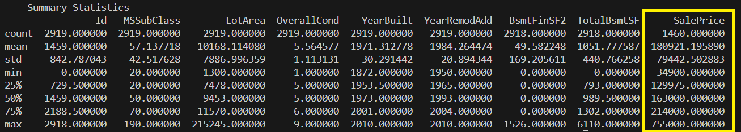
House prices show high variability, with some properties priced significantly higher than others. The higher mean compared to the median suggests a right-skewed distribution, where a few expensive houses increase the overall average. This also indicates the possible presence of outliers in the dataset.
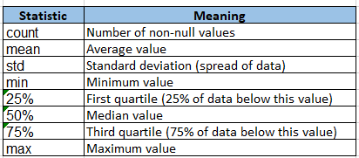

Check the distribution of the target variable “SalePrice”
Code
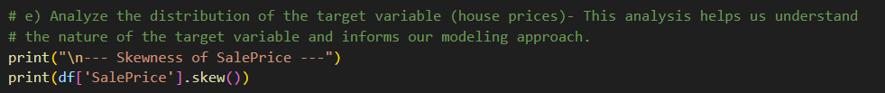
Output
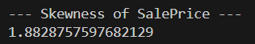
A skewness value greater than 1 or less than -1 indicates a highly skewed distribution, which may require transformation (e.g., log transformation) to improve model performance. The higher mean compared to the median suggests a right-skewed distribution
Principle:
Mean > Median : → right skew.
Mean < Median : → left skew.

Mean : 180921.195890,. Median (50%): 163000.000000,

Visualize the distribution of target variables
Code
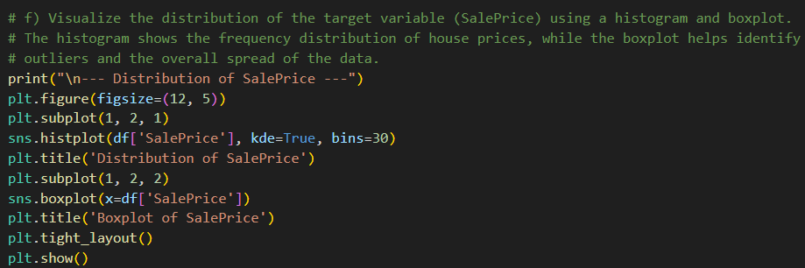

Output
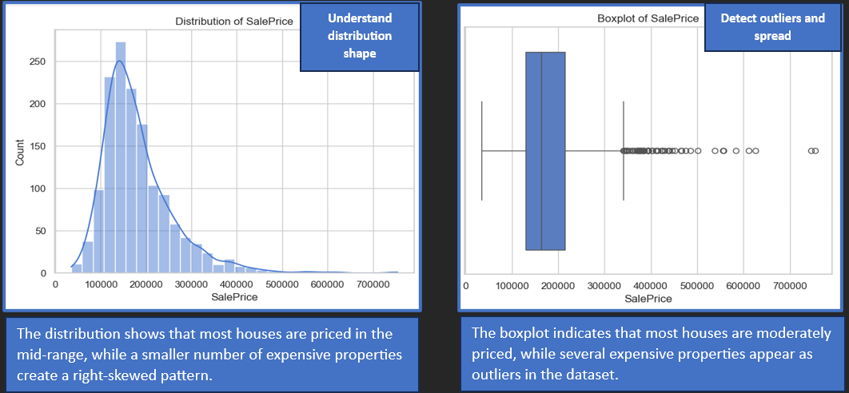

Step 4- Pre-Processing of data

4-a: Handle Missing Values
Code
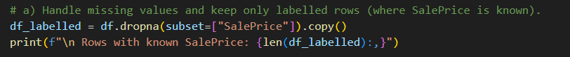
Output
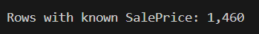

4-b: Drop Non-Essential Columns
Code
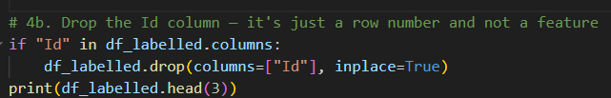

Output
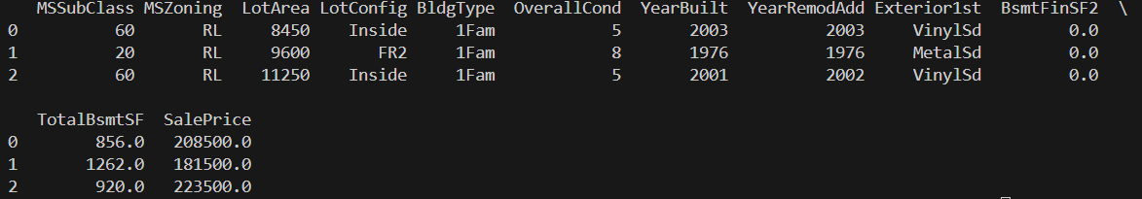

4-c: Check Missing Values in Labelled Dataset
Code
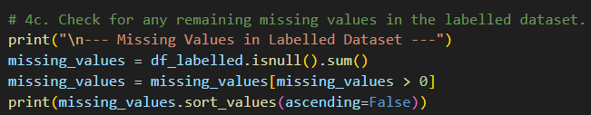

Output
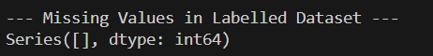

4-d: Check for duplicate values
Code
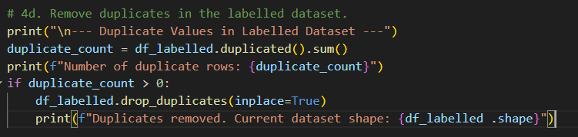
Output
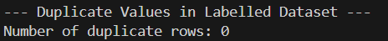

4-e: Separate Categorical and Numerical columns
Separate categorical and numerical columns for appropriate preprocessing, while excluding the target variable (SalePrice) from feature processing.
Code
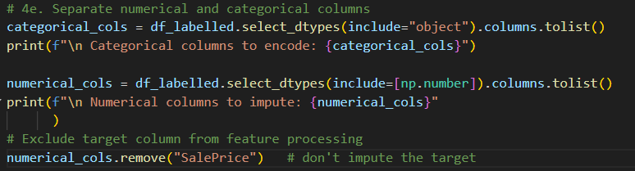
Output
For refence only (Categorical columns in yellow box) – Id column dropped
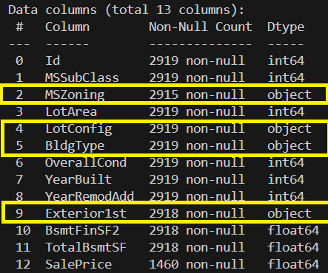

4-f. Fill missing numerical & categorical values and Validate values
Code
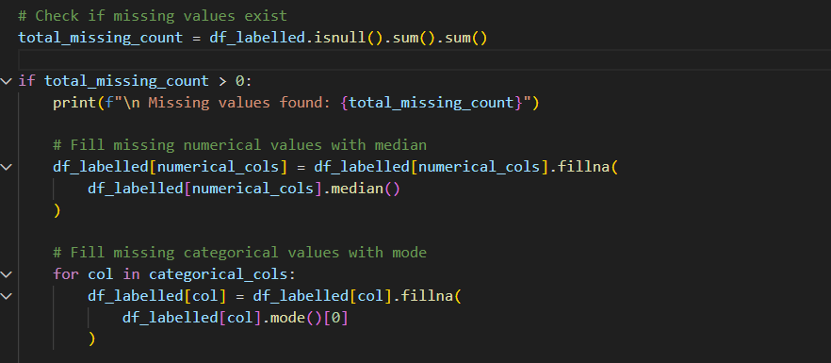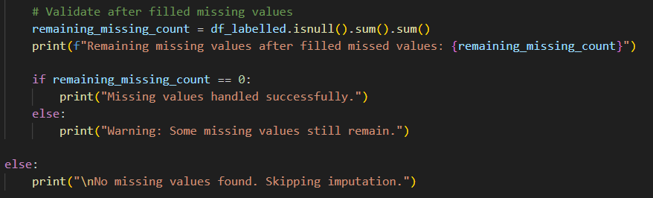
4g and 4h is part of above code
Output

4-i. Validate Duplicate Removal
Code
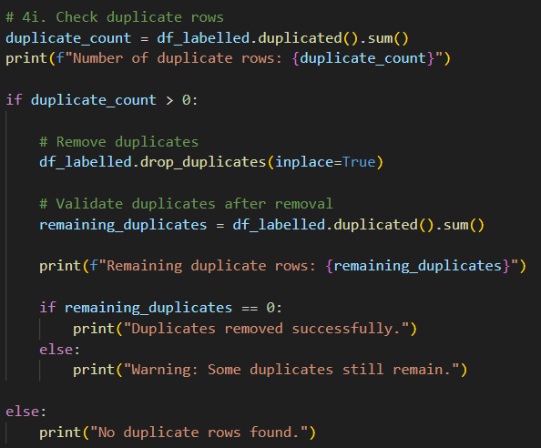
Output
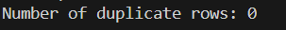

4-j: Encode Categorical Variables
Code
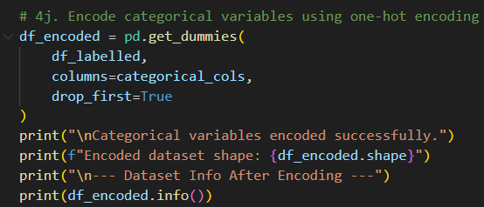
Output
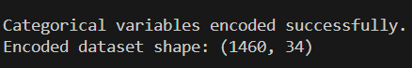
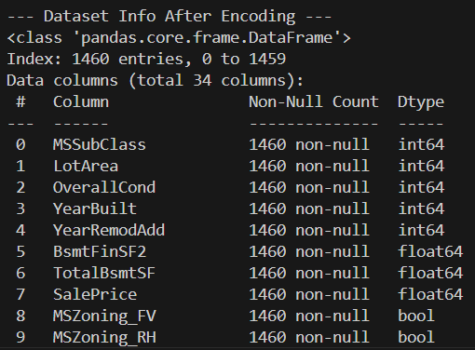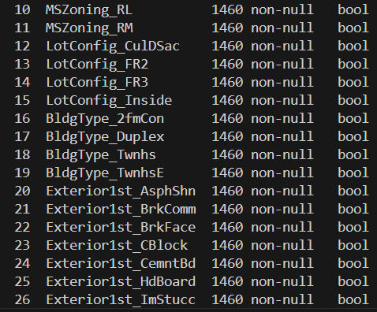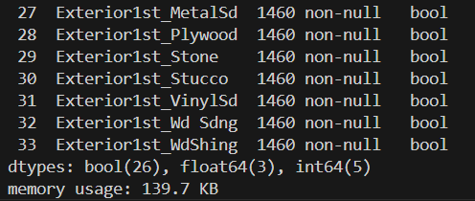

4-k: Separate Features and Target Variable
Code
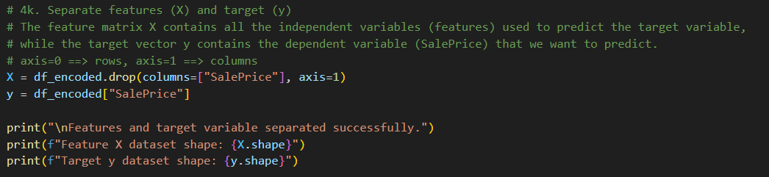

Output
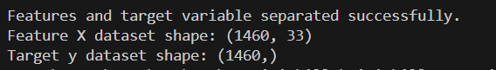

Task1-Train-Test Split
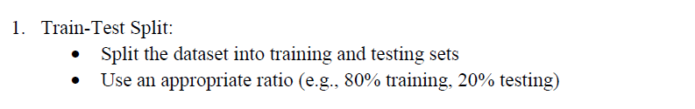
Code
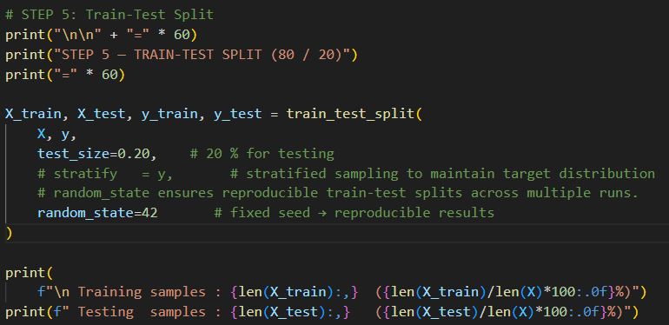
Output
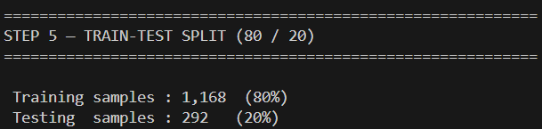

Task2-Train Model
          - 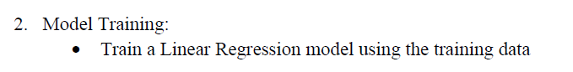
Code
          - 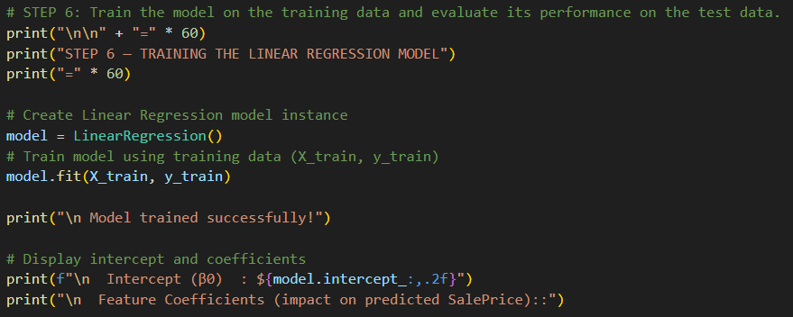
Output
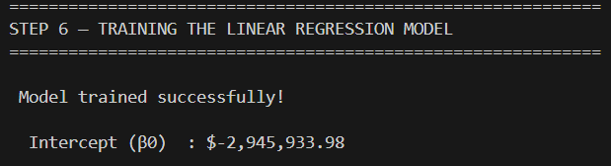
          - The intercept is the model’s starting prediction when all feature values are zero.

Code
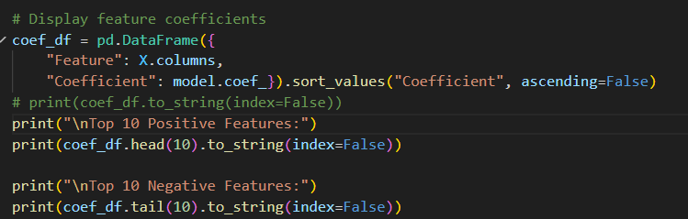

Output-1
            - 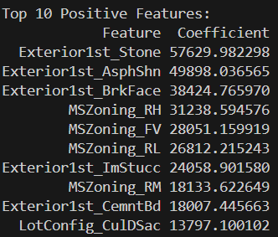
A positive coefficient means the feature contributes to a higher predicted SalePrice.

Output-2
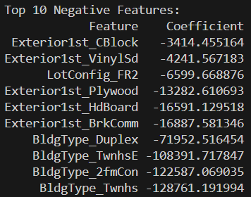
A negative coefficient means the feature contributes to a lower predicted SalePrice.

The absolute value of the coefficient reflects the strength of that feature’s influence, assuming all other variables remain constant.

Task3-Model Prediction
    - 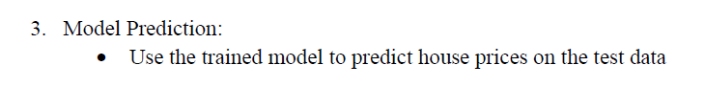
Code
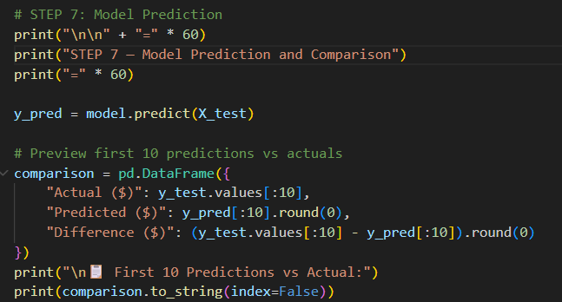
Output
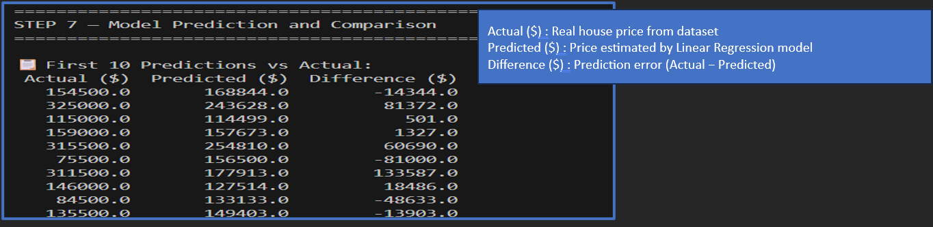
- The table shows how the model’s predicted house prices compare with the actual sale prices.
- Smaller gaps between the two indicate that the model predicted accurately.
- Larger gaps highlight cases where the model’s estimate was less reliable.

Task4-Model Evaluation
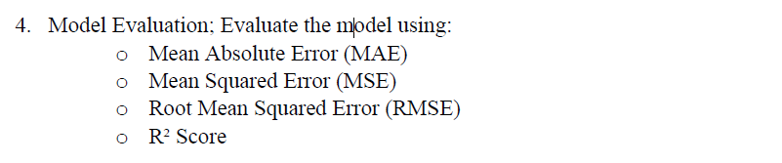
Code
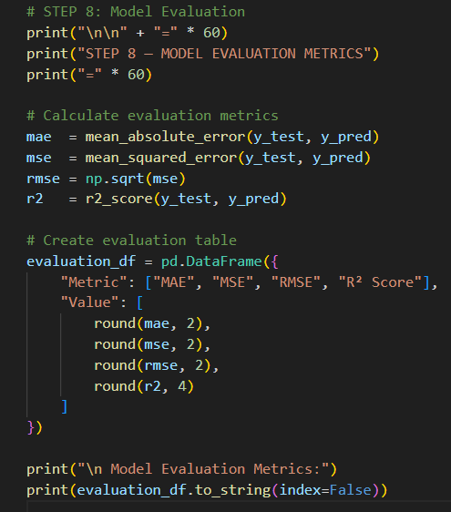

Output
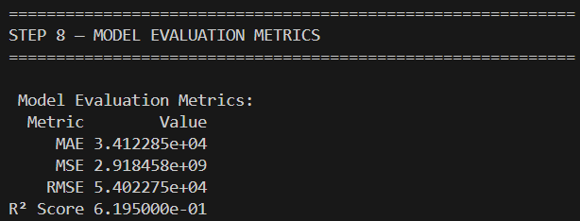
• The model achieved an R² score of approximately 0.62, meaning it can explain around 62% of the variation in house prices based on the selected features.
• The MAE (Mean Absolute Error) and RMSE (Root Mean Squared Error) indicate that prediction errors are typically between $34,000 and $54,000.
• Overall, the model successfully captures key house pricing patterns and provides reasonably accurate predictions, although further improvements could still enhance prediction accuracy.

Task5-Interpretaton
The Linear Regression model achieved an R² of 0.62 and an RMSE of $54,023, showing that it captures the overall relationship between house features and prices but is affected by outliers and non‑linear patterns. While some predictions were close to the actual sale prices, others showed larger gaps, suggesting the model struggles with certain property types or complex pricing factors. Overall, the model provides reasonably reliable estimates for a basic Linear Regression, though accuracy could be improved by exploring more advanced machine learning approaches.

